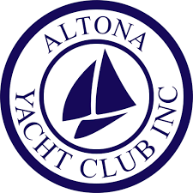

FIRST AID POLICY OF THE ALTONA YACHT CLUB, INC.

Rationale

Sports First Aid First aid and immediate injury management are important in the prevention and treatment of injuries at the time they occur.

Who is affected by this policy?

This policy applies to all guests, participants, members and volunteers of the Altona Yacht Club. Unless otherwise defined:
- Club Means the Altona Yacht Club Incorporated.

First Aid
The Club will, where possible, have suitably qualified first aiders present at all sailing and training sessions. The Club will encourage qualifications that are up to date at the start of each season.

First Aid kit
a first aid bag containing sufficient and varied material required to treat the most frequent of sailing injuries is located at the sign on Board The contents list will be reviewed annually by the AYC Treasurer and First Aid Coordinator:
- Saline
- Gauze
- Latex gloves
- Band-aids
- Non-adhesive and adhesive dressing – various sizes
- Scissors
- Adhesive tape
- Bandages – various types
- Triangular bandages
- Cold Pack (Spare whistle)

As material gets used, they are replaced via request to the AYC Treasurer or the First Aid Coordinator. AYC will at all times make available at training and games a fully equipped medical first aid supply.

Ice will also be available at the AYC.

Emergency telephone numbers of local hospitals, the ambulance service and other key numbers will be clearly visible at each and every phone within the clubhouse and notice boards.

Timing
This policy is effective from 24th July 2024

For and on Behalf of its Members. The Altona Yacht Club Inc. Board

